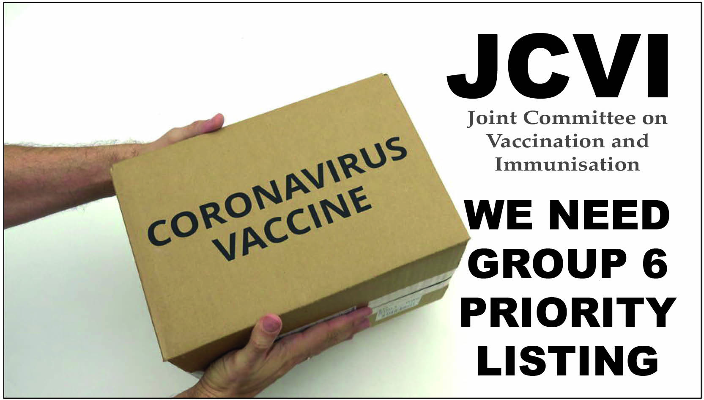

TEMPLATE LETTER TO YOUR GP

PLEASE MODIFY IT TO SUIT YOUR PARTICULAR CIRCUMSTANCES.
THEN COPY AND PASTE TO YOUR OWN LETTERHEAD OR EMAIL.
MAKE SURE IT’S DATED AND SIGNED, CONTAINS YOUR HOME ADDRESS AND DATE OF BIRTH –THEN EITHER EMAIL IT OR SEND BY ROYAL MAIL
Dear XXXX,

I am writing to ascertain if, due to having ME/CFS, I have been added to the 'group 6' list for Covid vaccinations.
The ME Association (MEA) has advised people with ME/CFS to check this with their GP surgeries, as not all GP surgeries have been adding people with ME/CFS to group 6 of the JCVI priority list.

The MEA has also provided the following background information for health professionals and has confirmed that people with ME/CFS are reporting that they have been placed in group 6 as a result of receiving this information.

1 People with a chronic neurological disease are listed as having an underlying health condition in group 6 in the JCVI guidance. See page 9 in Chapter 14a of the ‘green Book' guidance on Covid vaccine:
https://assets.publishing.service.gov.uk/government/uploads/system/uploads/attachment_data/file/955548/Greenbook_chapter_14a_v6.pdf

2 Both the World Health Organisation (in ICD10 section G93.3) and NHS England classify ME/CFS as a neurological disease:
https://www.england.nhs.uk/ourwork/clinical-policy/ltc/our-work-on-long-term-conditions/neurological/

3 Even though ME/CFS is not included as a specific disease in the ‘green book’ list of neurological conditions, the guidance makes it clear that the list is not exhaustive.

4 The 'green book' guidance (page 10) states that:
The examples above are not exhaustive, and, within these groups, the prescriber should apply clinical judgment to take into account the risk of COVID-19 exacerbating any underlying disease that a patient may have, as well as the risk of serious illness from COVID-19 itself.

5 New infections are probably the commonest cause of exacerbation or relapse of ME/CFS - as noted in section 3.3.2 of the Chief Medical Officer’s Working Group Report on ME/CFS:
https://meassociation.org.uk/wp-content/uploads/CMO-Report-2002.pdf
and in section 1.6.4 of the new (draft) NICE guideline on ME/CFS which will become operational in April 2021:
https://www.nice.org.uk/guidance/gid-ng10091/documents/draft-guideline

6 Patient evidence to the MEA also indicates that almost everyone with ME/CFS who has caught COVID-19 has had a significant and/or prolonged relapse of their ME/CFS. This is not surprising given the considerable degree of clinical overlap between ME/CFS and Long Covid.

I would therefore be very grateful if you could confirm that I have been added to the Group 6 list.

To ensure that I can be contacted as soon as I am eligible, please add my mobile number to my file to be contacted by this, if not already saved there.

Thank you very much in advance for your time and indeed for everything you and your other NHS colleagues are doing during this pandemic.

Kind regards,
Full name
Address
Date of birth

